**eBalance-Kit database upgrade test report**

from version 1.5 to version 1.6

# Scope

The purpose of this test report is to test the eBalance-Kit database upgrade from version 1.5 to version 1.6.

# Related Documents

**Title** **Version**

Testing the database upgrade for SQLite, MySQL and SQLServer 1.0

# Test Equipment

The test equipment used eBalance-Kit test:

* eBalanceKit Config tool released 1.5.6
* eBalanceKit Database Management tool released 1.5.6
* eBalanceKit released 1.5.6
* eBalanceKit Database Management tool version 1.6 (from SVN)
* eBalanceKit version 1.6 (from SVN)
* MySQL database local instance
* SQLite database local instance
* SQLServer database at edna.av.local

# Test Results

## Summary

Most of the values were correct in upgrade process, but there were problems with a few fields. .

## Passing Tests

All test results are documented in attached XLS document.

## Test Failures

All test results are documented in attached XLS document.

## Deviations from Planned Testing

Needed to modify the DatabaseManagement solution because it didn’t compile.

The edna.av.local MSSQL database didn’t accept the Database Management database upgrade script. The database needed to be modified by Database Management solution (DatabaseManagement/DbUpgrade/Upgrader.cs).

## Defects / Problem Reports

Very important experience:

-There was a common issue with all of the database types. After the upgrade if the value of an assigned account was 0 euro, after the upgrade the bill disappeared from the treeview.

-A few fields changed from text type to datetime, and that’s why they couldn’t keep their original values.

The fields:

*VerWaltung -> Unternehmen -> Allgemein -> Hausnummer* (only in MSSQL)

*Report -> Allgemeine Informationen -> Dokumentinformation -> Dokumentrevisionen -> aktuelle Versionsnummer Dokument*

-On this screen the last six datetime values didn’t keep their values:

*Report -> Allgemeine Informationen -> Informationen zum Bericht -> Angaben zur Berichtsperiode*

-After adding some reconciliation values in *Bilanz* screen, the database upgrade was started but in MySQL and MSSQL the upgrading process crashed with errors. See the error messages at end of this document in 4.6 Error screenshots section. The reconciliation values successfully kept in SQLite.

## Quality Assessment

A few menus and fields were completely changed or removed in the old or in the new version of eBalanceKit. The new screens that doesn’t existed in older version, weren’t tested.

For example:

*VerWaltung -> Unternehmen -> Mutterunternehmen* doesn’t exist in version 1.5.

## Additional information

-

## Error screenshots

Reconciliation errors:

MSSQL error during database upgrading process in Database Management:

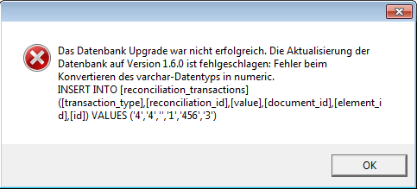

MvSQL error during database upgrading process in Database Management:

